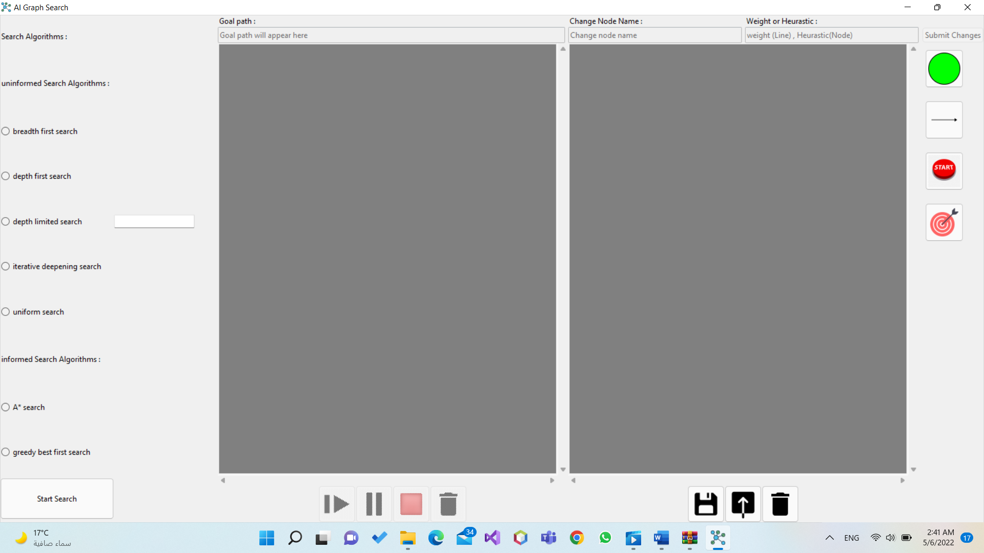**User Guide**

Figure : Graph Search Application

At first in order to use the graph search application which is shown in (fig.1) you have to make a graph to be able to apply the search algorithms shown in the application.

To build a graph you will start by inserting the number of nodes that you prefer at the board in the right side by pressing on the green circle which represents the nodes (fig.2) then press at the board the number of times you prefer, as per every press you make at the board a node is inserted.

Figure : How to insert a node

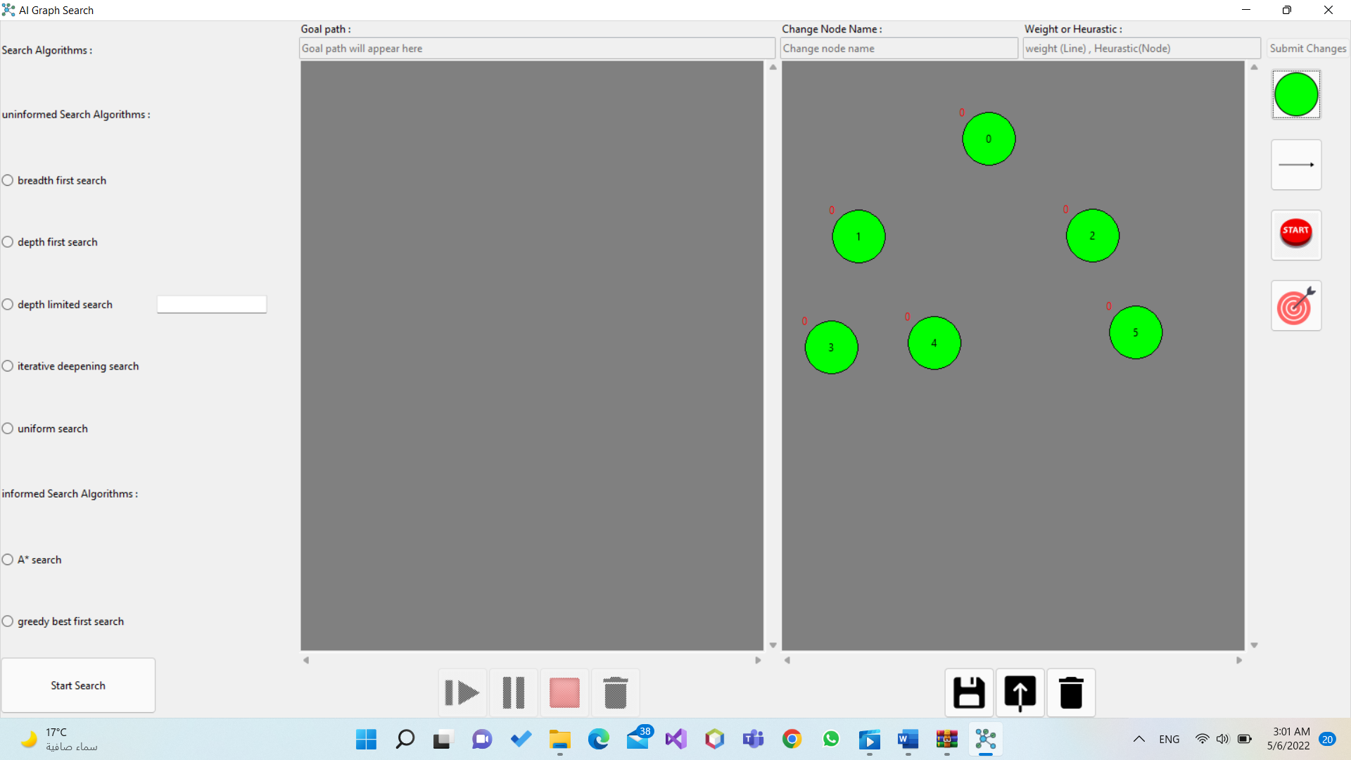Ex: Inserting 6 nodes (fig.3).

Figure : Inserting 6 nodes

After inserting the nodes, you will have to connect these nodes to make the able to interact with each other to reach the goal you need.

To connect the nodes, you will have to press on the arrow at the right shown in (fig.4) then select the node which the arrow is going from then the node the arrow is going to.

Figure : How to connect nodes

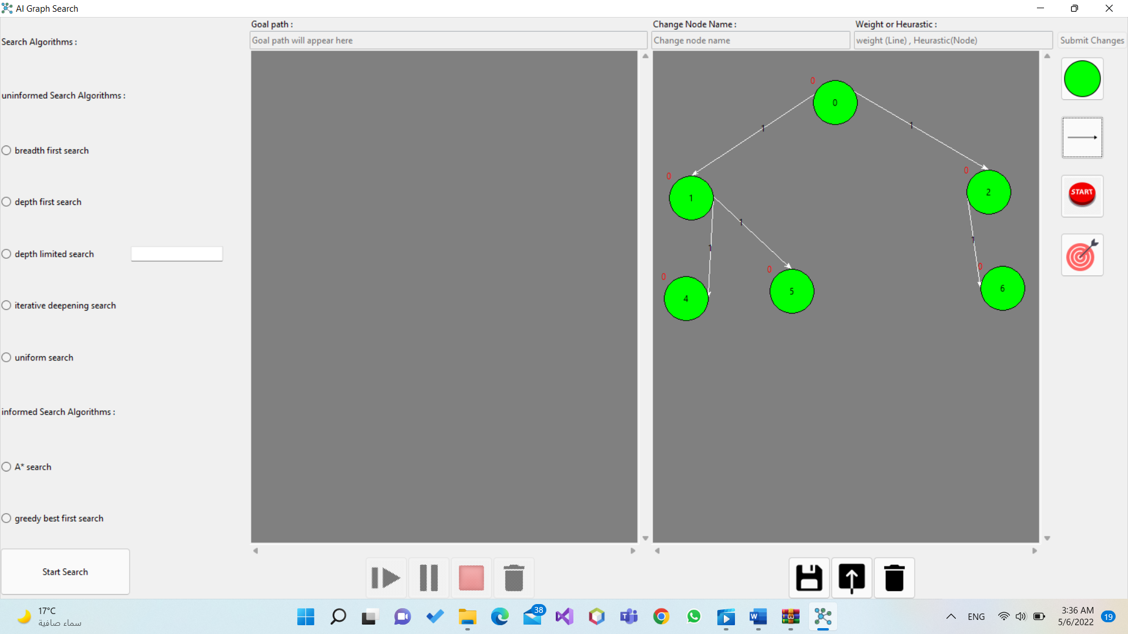Ex: Connecting nodes (fig.5).

Figure : Connecting nodes

After inserting nodes and connecting them you will have to assign a node to start from and a goal node, you can assign more than one node as a goal but at first assign only one start and one goal to make it easy for you till you get used to it.

In order to assign a node to start from you will press on the button which contains the word start at the right shown in (fig.6) then select which node you want as a start.

To assign a node as the goal you will press at the last button on the right shown in (fig.6) then select which node you want as the goal.

Figure : How to assign start and goal nodes

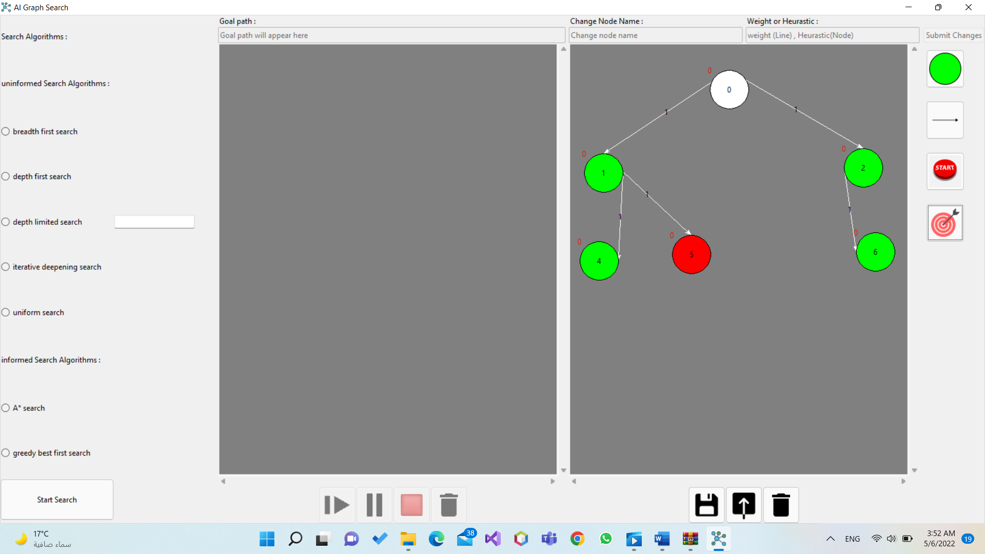Ex: Assigning (node 0) as the start which its color changed from green to white as it is the start and (node 5) as the goal and its color also changed to red as it is the goal (fig.7)

Figure : Assigning nodes

After building the graph and assigning the start and the goal nodes you can remove or edit any node or connecting line you need.

In order to remove any node or connecting line you will have to select this node or line by pressing on them then pressing delete or backspace from the keyboard.

To edit any node and by editing, I mean changing names of the nodes or changing their heuristic cost to do that you’ll select the node by pressing on it then start typing on the top left bar shown in (fig.8) to change its name, and at the top right bar shown in (fig.8) also to change its heuristic cost then press submit changes which is shown in (fig.8) as well.

The operation of changing the heuristic cost applies to all the nodes except the goal node as studied the heuristic cost of the goal node is equal to zero, so even if you tried to change it, it’ll remain as it is by default equal to zero.

To edit any connecting line which means changing its weight or cost you’ll select the line by pressing on it then you’ll start typing on the top right bar shown in (fig.8) to apply the cost or weight that you need then press submit changes which is shown in (fig.8).

Figure : Editing nodes and lines

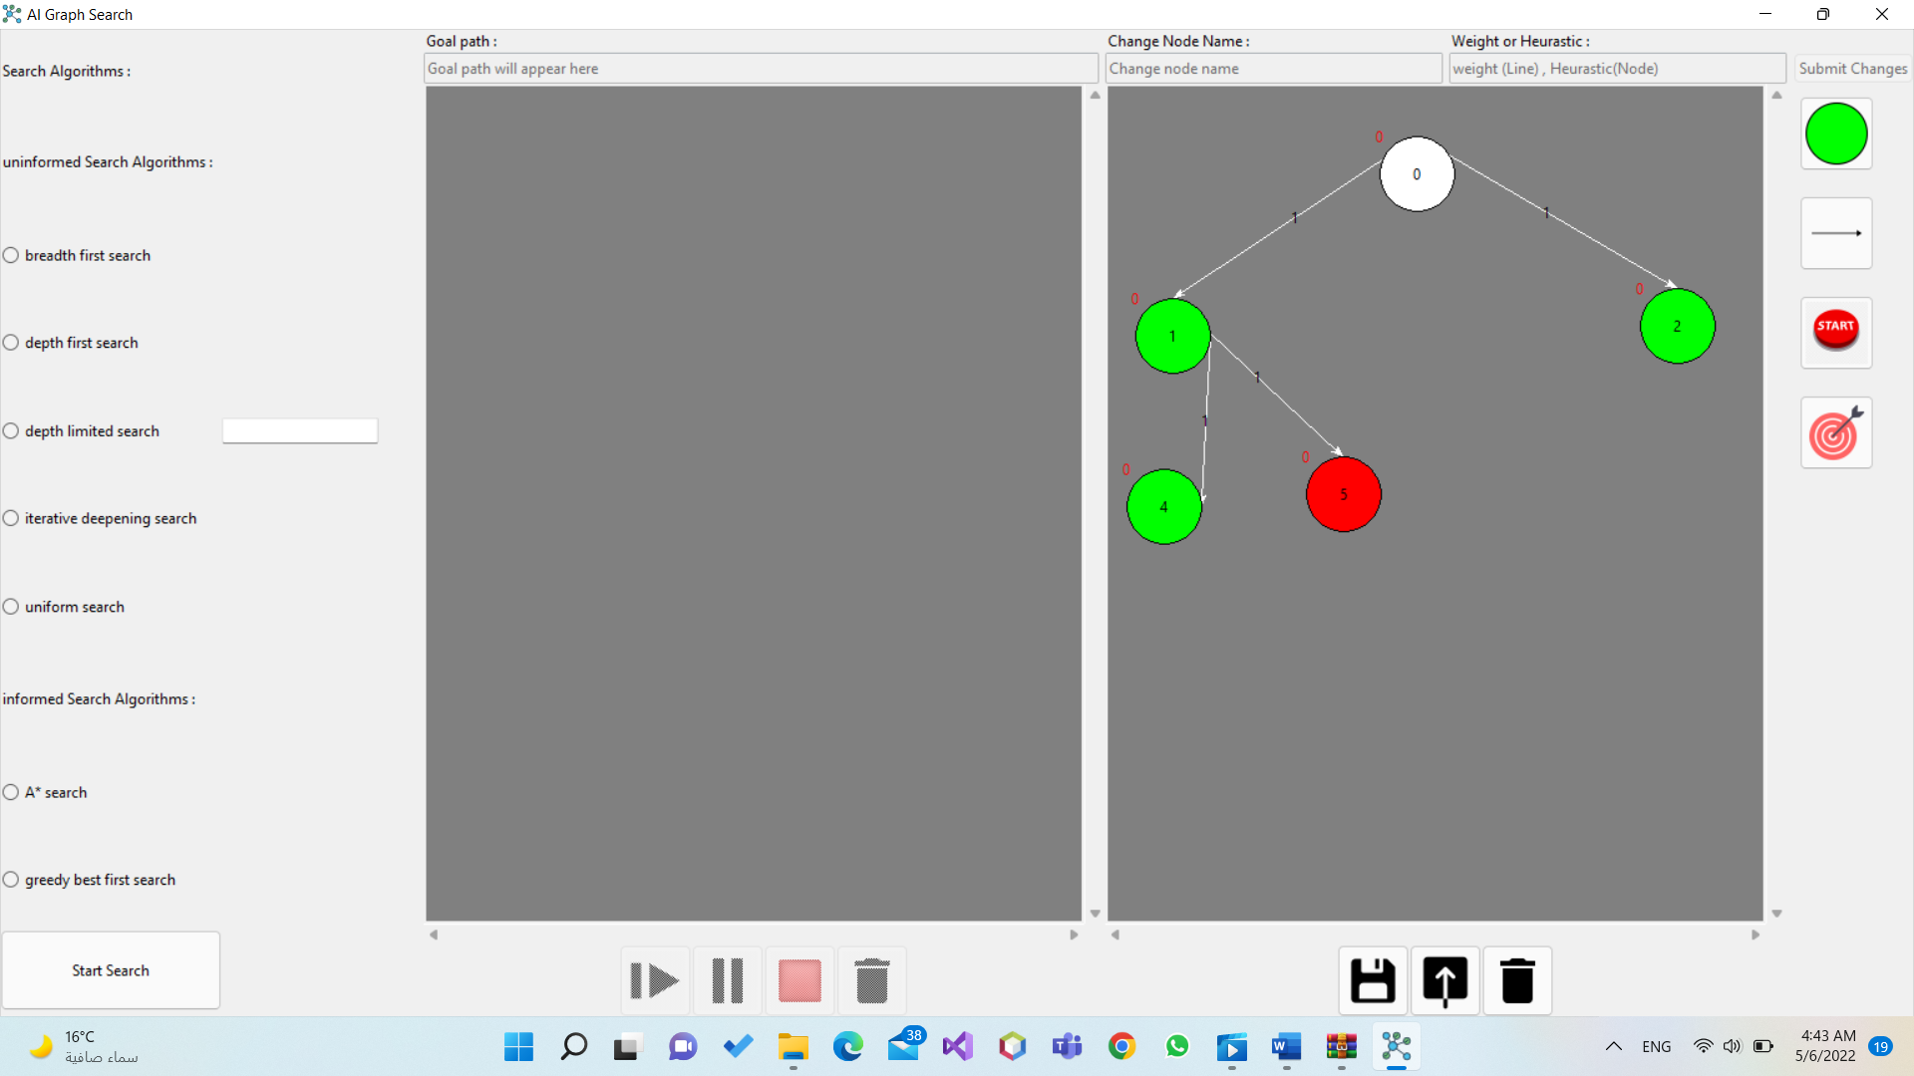Ex: Removing (node 6) and its connecting line from the graph (fig.9).

Figure : Deleting nodes and lines

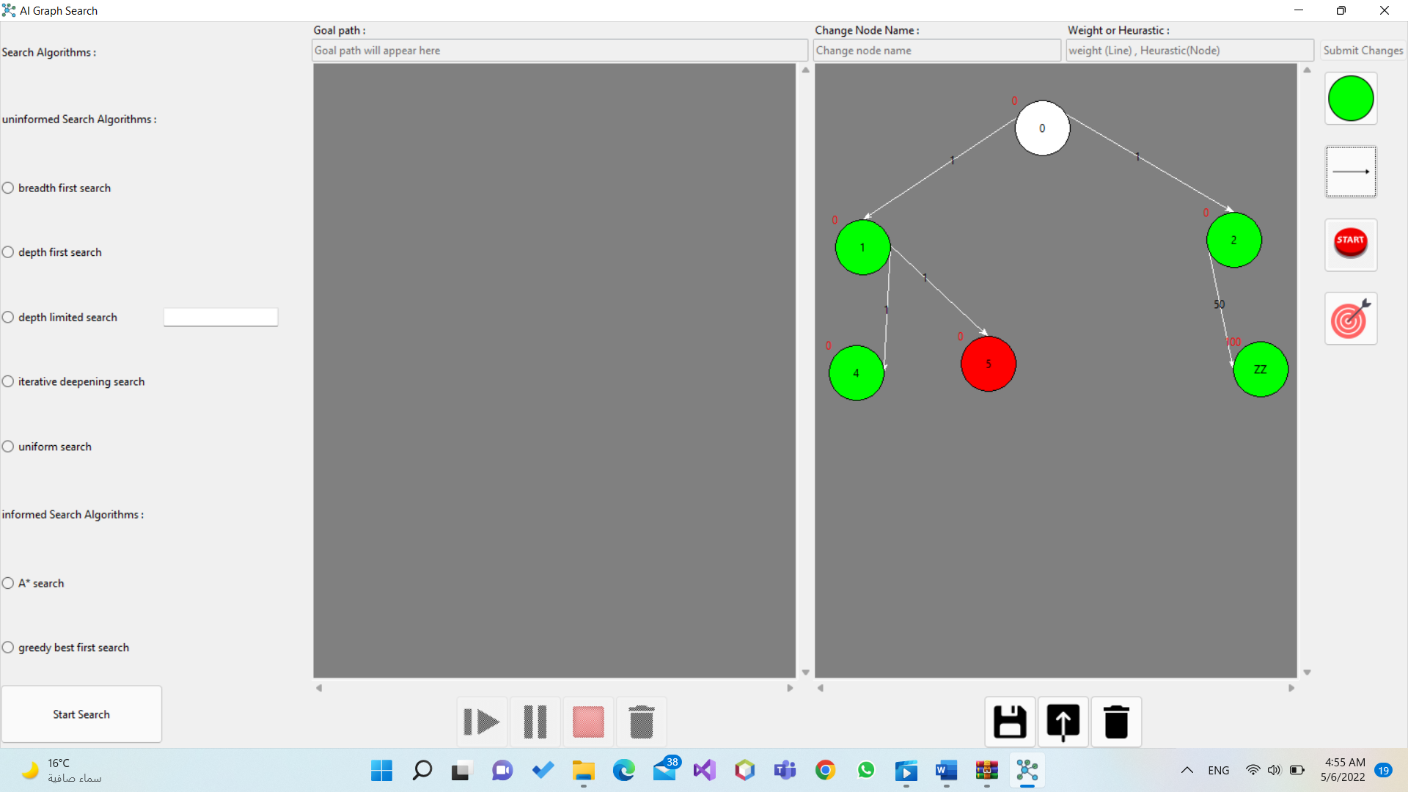Ex: Changing name of (node 6) to “ZZ” and its heuristic cost to “100”, and changing the weight or the cost of the line to 50 (fig.10).

Figure : Editing nodes and lines

After building the graph and applying all the changes that you need on it you can save it or delete it, to save it you will press at the button at the bottom left shown in (fig.11), to delete it you will press at the button at the bottom right shown in (fig.11) as well.

Figure : Saving and Deleting Graph

Ex: In my case I saved the graph by the name “Sample” then I deleted it (fig.12).

Figure : Saving the graph then deleting it

In order to get the saved graph and start operating on it you’ll have to press on the button in the middle bottom between the saving and deleting buttons shown in (fig.13).

Figure : Showing saved graphs

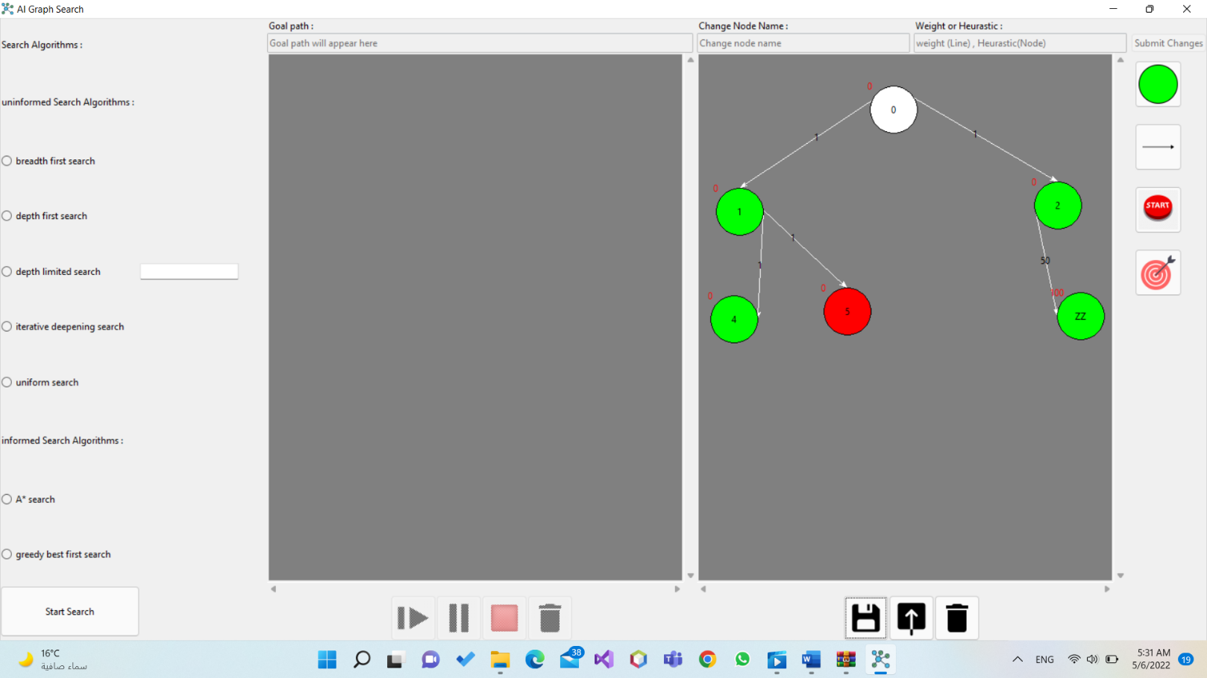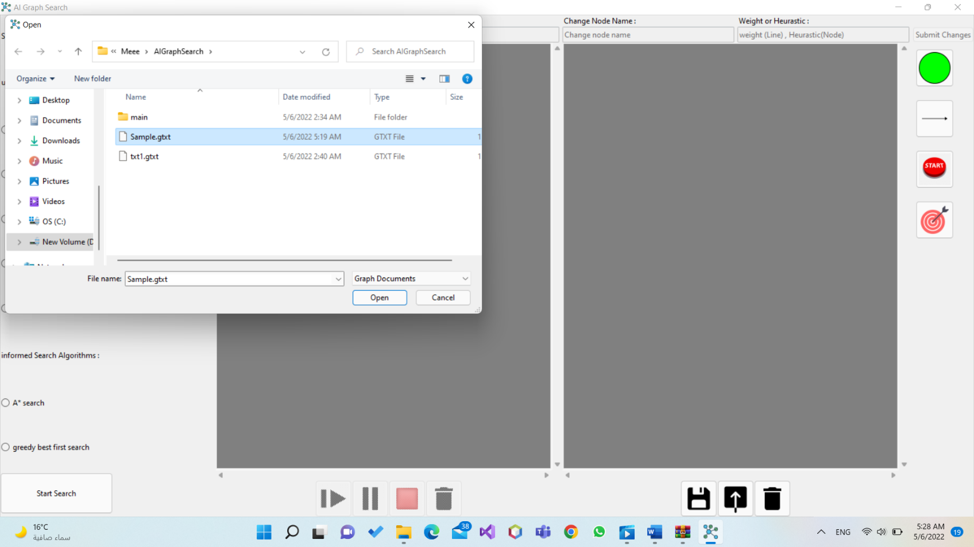Then select the saved graph you want to operate on from your previous graphs then press open as shown in (fig.14).

Figure : Opening a previously saved graph

Now you have known how to build, edit, save and delete a graph the second step is to know how to operate on that graph to attain your goal.

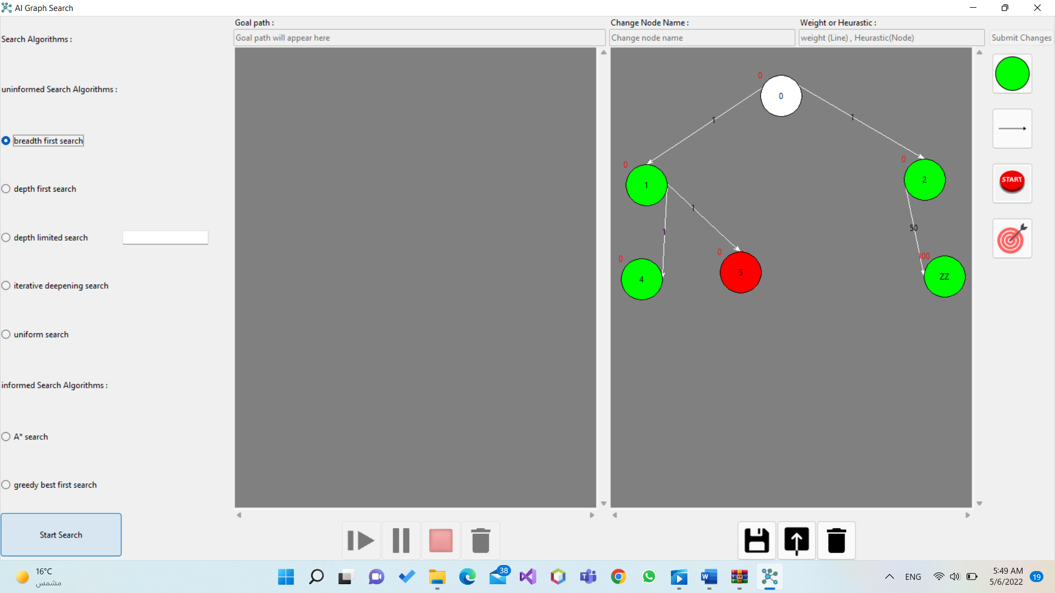Firstly, you have to select which searching algorithm you want to apply on that graph (in case of the depth limited search you have to enter the limit of the levels you want to application to reach shown in (fig.15)) to select the algorithm you just have to press on it then press on “Start Search” button shown in (fig.15)

Figure : Selecting Search Algoritm

After selecting the algorithm and pressing on start search you can operate on the search happening by pausing it by pressing on the second button shown in (fig.16), or letting it to continue by pressing on the bottom left button shown in (fig.16), or stopping it at all by pressing on the red button shown in (fig.16) also, finally you can delete the solution by pressing on the bottom right button shown in (fig.16) as well.

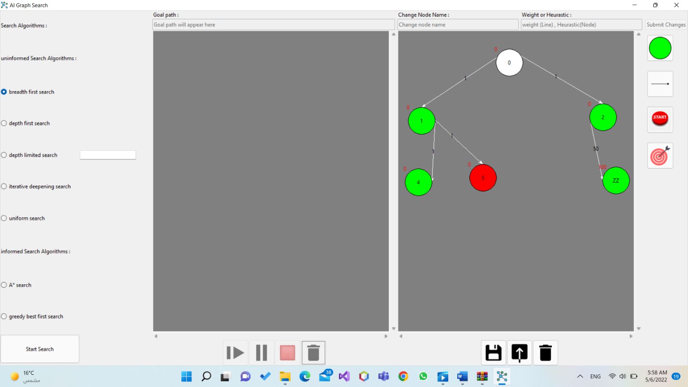

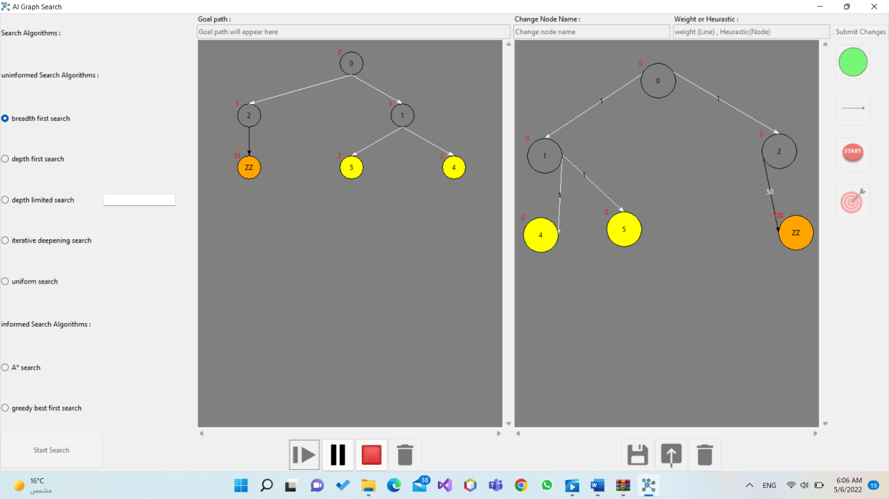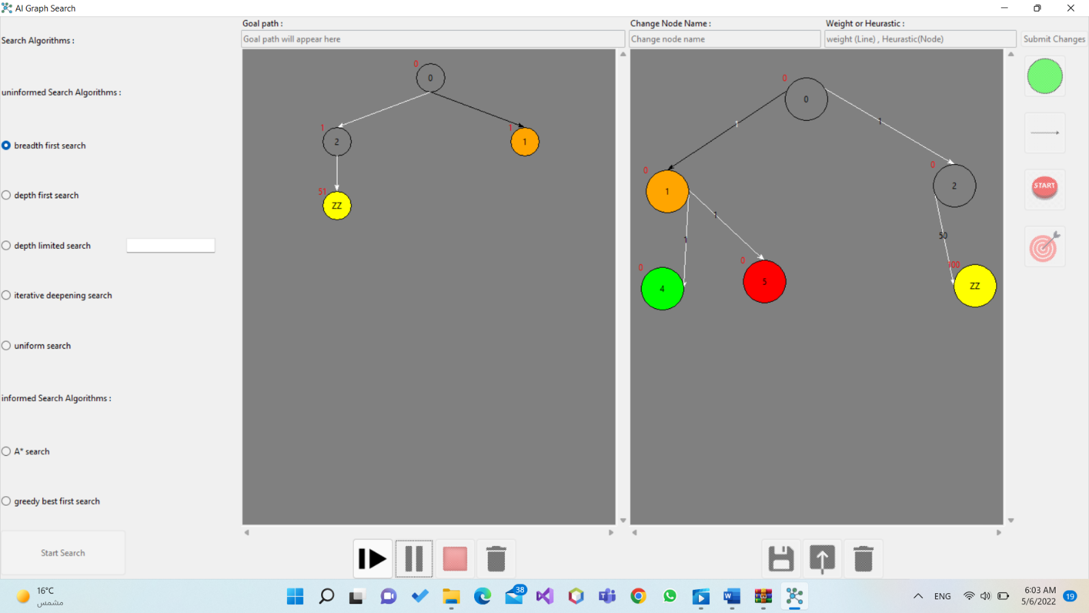Ex: I chose breadth first algorithm then I paused the algorithm, then I played it back, then I stopped it at all, then I deleted it show in the figures below.

Figure : Playing the algorithm back

Figure : Pausing the algorithm

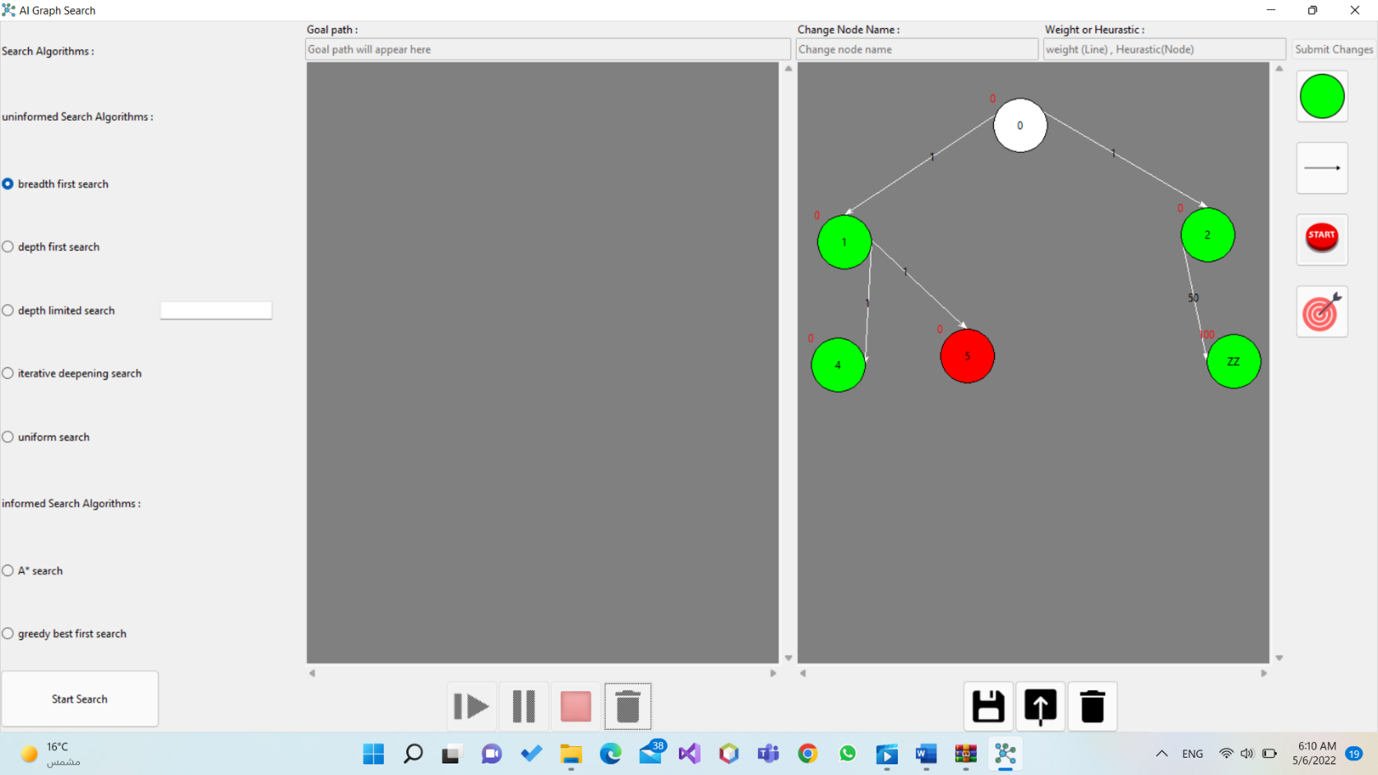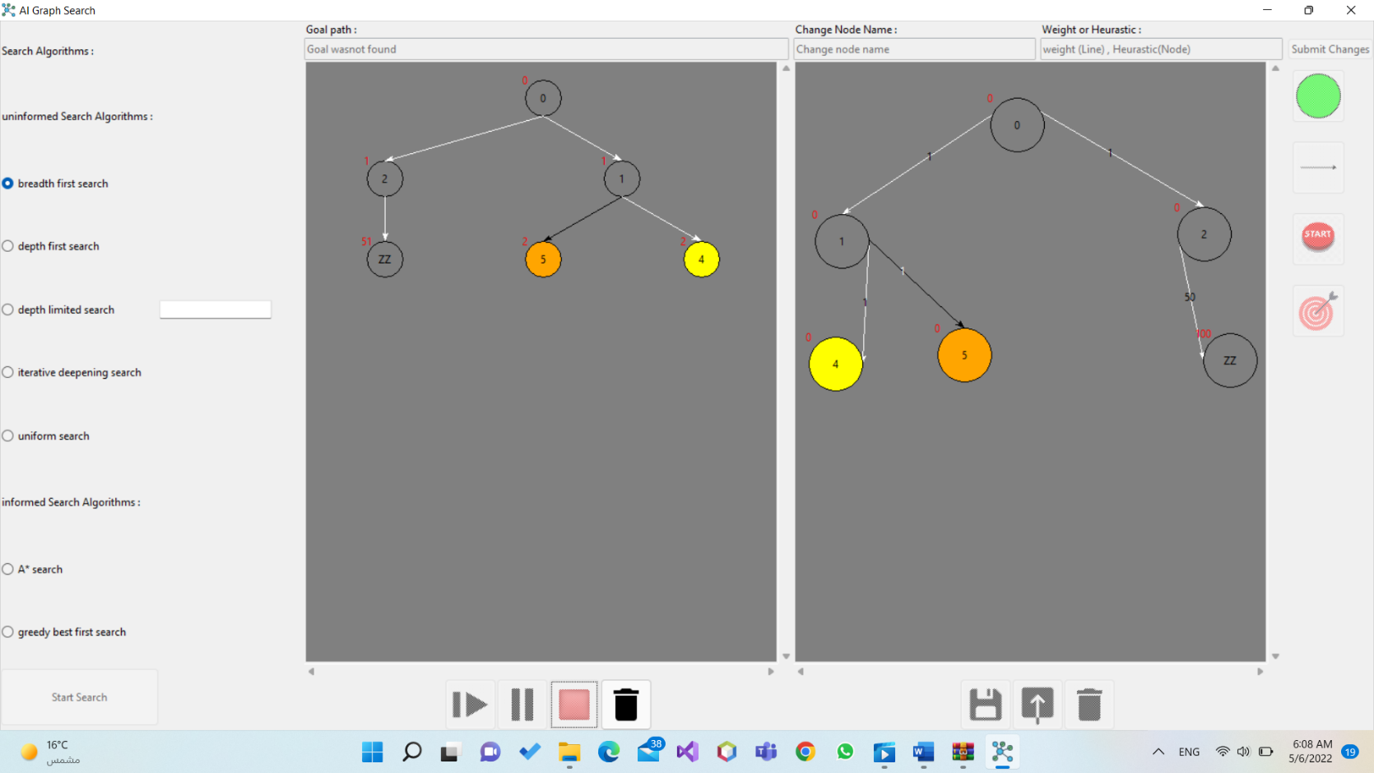

Figure : Stopping the algorithm at all

Figure 19: Deleting the graph done at all

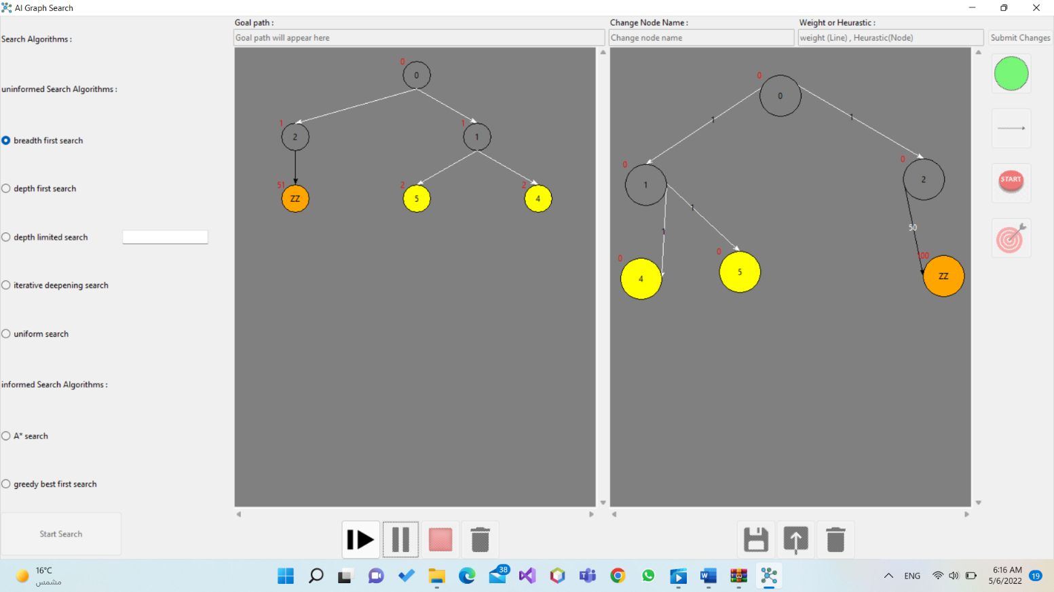While the algorithm is working the visited nodes are colored in orange color an the unvisited remain yellow as shown in (fig.20).

Figure 20: Coloring the visited nodes

After the algorithm finishes it colors the goal path in violet and the goal path is written on the top left bar shown in (fig.21)

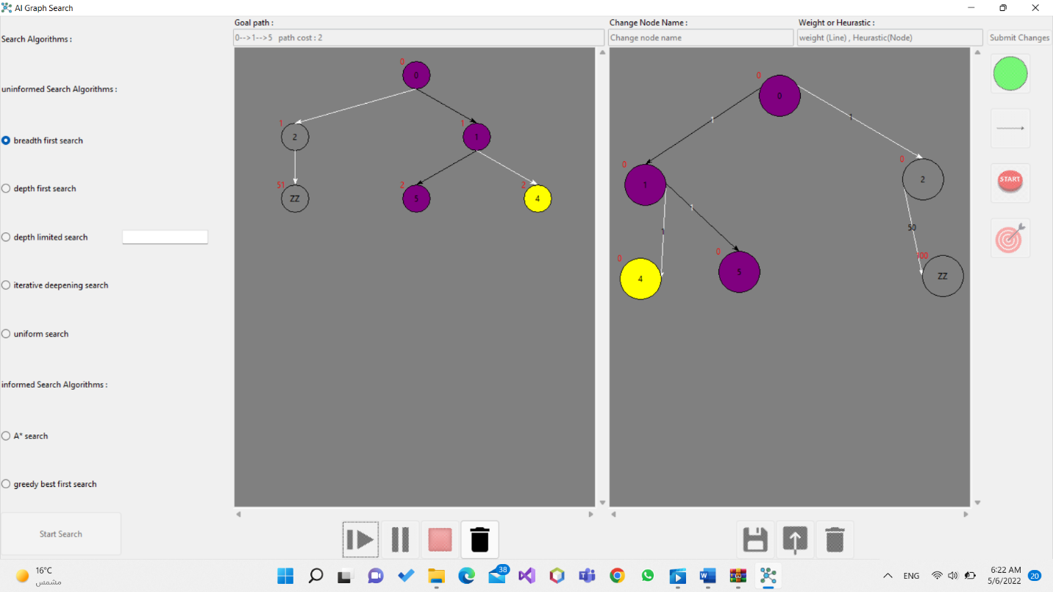

Figure 21: Showing the goal path

*Colors of the application:*

White: Initial node

Red: Goal node

Yellow: Fringe node

Grey: Visited nodes

Orange: Active node

Crossed(x): Already visited nodes

Violet: Goal path nodes